Quiz 2

Problem solving: Pseudo Code and flowcharts

- Make a flow chart for the following :
In a company, there are deductions from the salary of the employees for a fund. The deductions rules are as follows: -
- If salary is less than Rs.10,000 then no deduction.
- If salary is equal to or more than Rs.10,000 and less than Rs.20,000 then deduct Rs.1,000 as fund.
- If salary is equal to or more than 20,000 then deduct 7 % of the salary for fund
Input salary from user and after appropriate deduction show the net payable amount
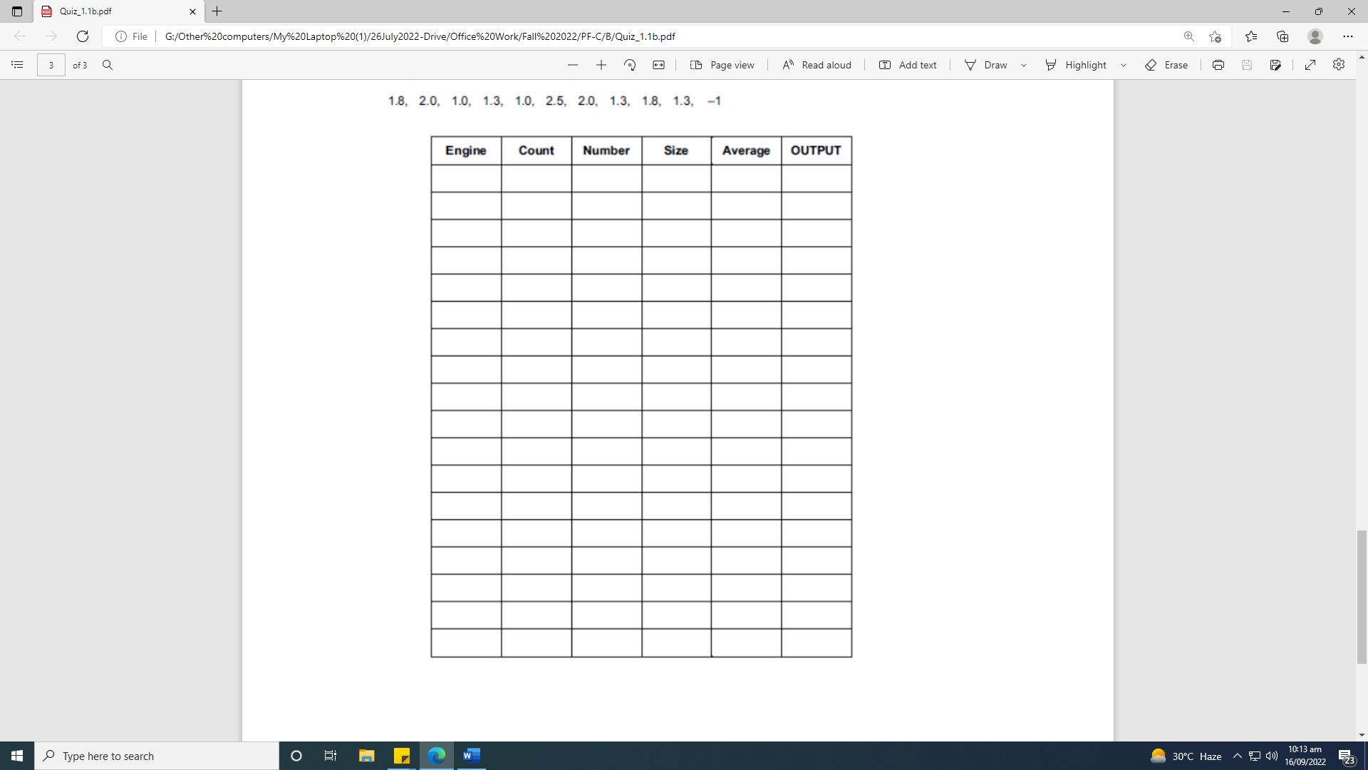
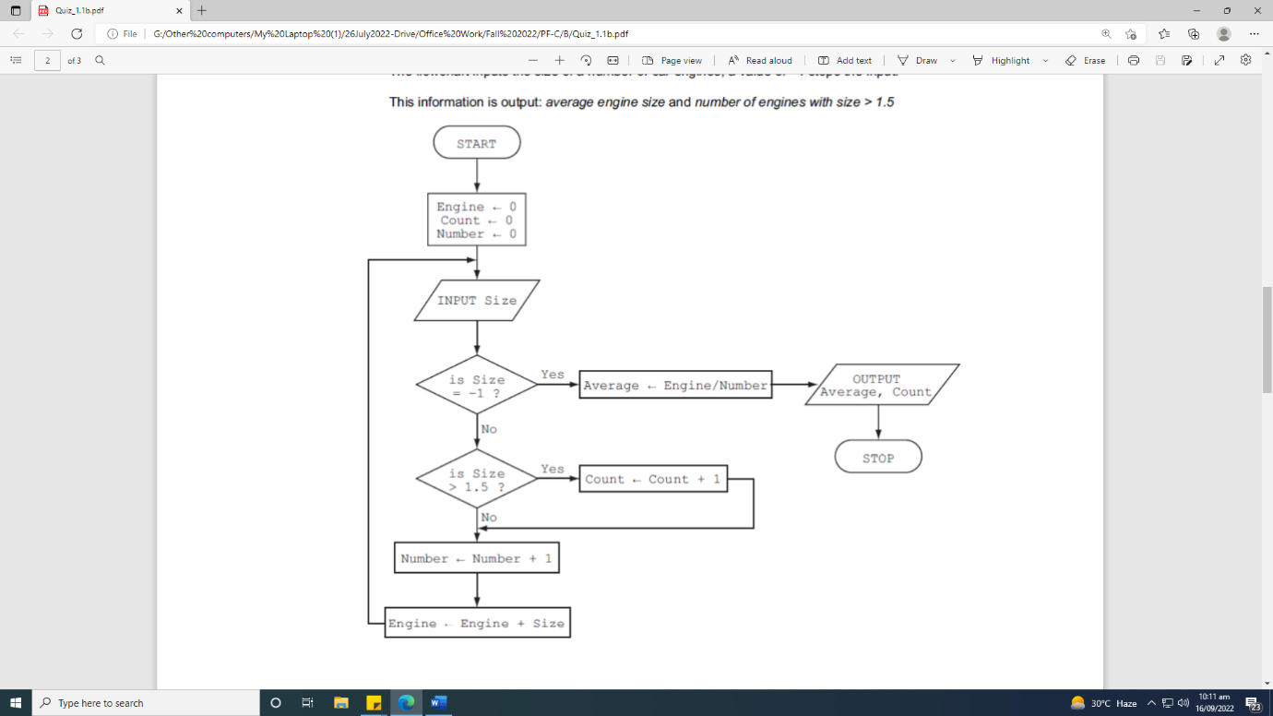
- What will be output of the following flowchart if Size is given as input in the following order: 3 2 1.5 0 1. Complete the trace table given below for each iteration.

